**Practical 04 Digital Presentation**

**Representing colour in RGB**

1. 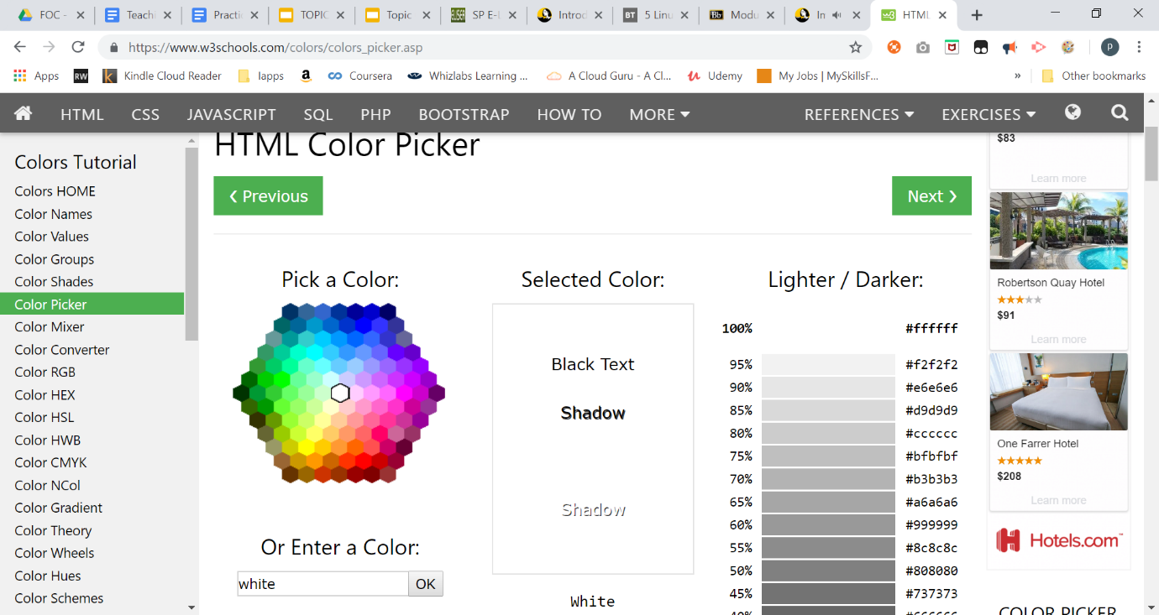Go to web site <https://www.w3schools.com/colors/colors_picker.asp>

|  |  |  |
| --- | --- | --- |
| **Colour** | **RGB in decimal** | **RGB In Hex** |
| Black | RGB (0, 0, 0) | #000000 |
| White | RGB (255, 255, 255) | #ffffff |
| Your favourite colour  (lavender blue) | RGB (204, 204, 255) | #ccccff |

Access the File Header

1. Using notepad, create a text file named “file1.txt”

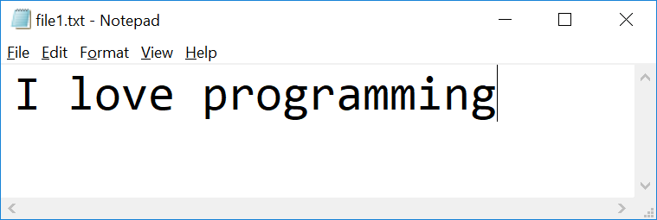

1. Check the file properties

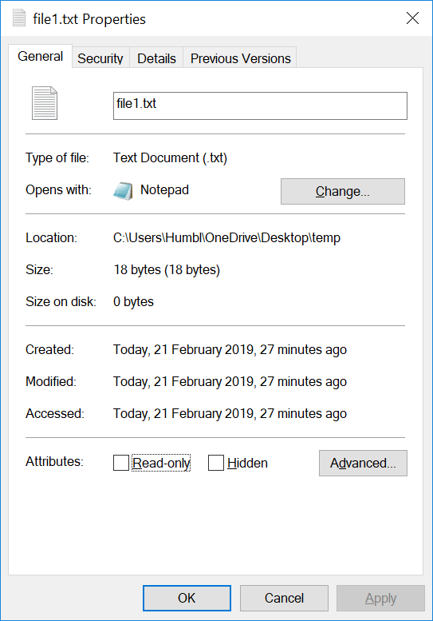

What is the size of the file in bytes?

|  |
| --- |
| 18 bytes |

1. Visit HexEd at <https://hexed.it/>

or download HxD Hex Editor

<https://download.cnet.com/HxD-Hex-Editor/3000-2352-10891068.html?part=dl-HxDHexEdi&subj=uo&tag=button>

1. Open file1.txt using HxD
2. Observe the Hex code  
   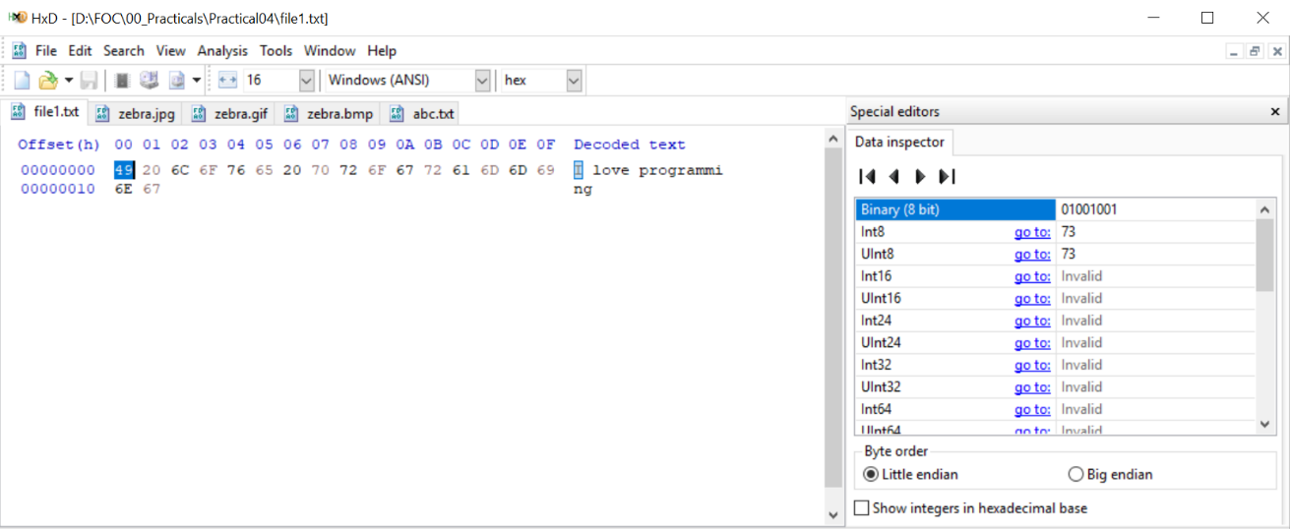

|  |  |  |
| --- | --- | --- |
| **Character** | **Hex** | **Binary(8 bit)** |
| I | 49 | 01001001 |

1. Using HxD to observe how character “o” and space character are represented

|  |  |  |
| --- | --- | --- |
| **Character** | **Hex** | **Binary(8 bit)** |
| o | 6F | 01101111 |
| space | 20 | 00100000 |

1. 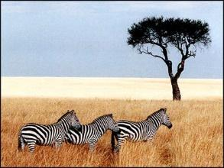Download the following image and save it as zebra.**jpg**, zebra.**gif** and zebra.**bmp**
2. Open **zebra.gif** in HxD

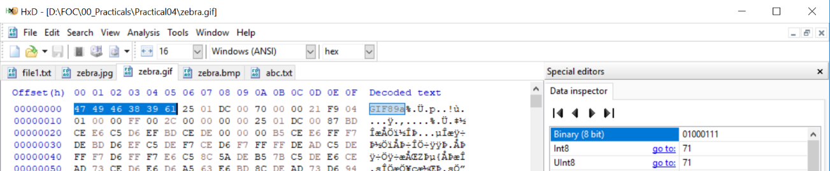Observe the Hex code

What are the **first 6 bytes** decoded?

|  |  |  |  |  |  |  |
| --- | --- | --- | --- | --- | --- | --- |
| **offset** | **00** | **01** | **02** | **03** | **04** | **05** |
| Byte | 01000111 | 01001001 | 01000110 | 00111000 | 00111001 | 01100001 |
| Character | G | I | F | 8 | 9 | a |

1. Visit web site <https://en.wikipedia.org/wiki/List_of_file_signatures> to find out the meaning of above hex code

|  |
| --- |
| Hex code: 47 49 46 38 39 61  ISO 8859-1(a single byte encoding that can represent the first 256 Unicode characters): GIF89a  Offset: 0  Extension: gif  Description: Image file encoded in the Graphics Interchange Format (GIF) |

1. Open **zebra.jpg** in HxD  
     
   Observe the Hex code

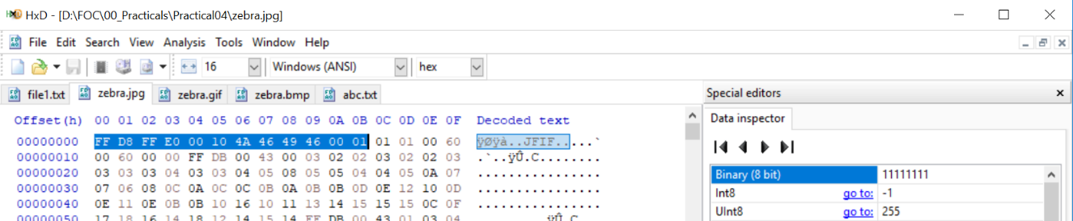

What are the **first 12 bytes**?

|  |  |  |  |  |  |  |  |  |  |  |  |  |
| --- | --- | --- | --- | --- | --- | --- | --- | --- | --- | --- | --- | --- |
| **offset** | **00** | **01** | **02** | **03** | **04** | **05** | **06** | **07** | **08** | **09** | **0A** | **0B** |
| Byte | 11111111 | 11011000 | 11111111 | 11100000 | 00000000 | 00010000 | 01001010 | 01000110 | 01001001 | 01000110 | 00000000 | 00000001 |
| Character | blank | ‡ | blank |  | . | . | J | F | I | F | . | . |

1. Visit web site <https://en.wikipedia.org/wiki/List_of_file_signatures> to find out the meaning of above hex code

|  |
| --- |
| Hex code: FF D8 FF E0 00 10 4A 46 49 46 00 01  ISO 8859-1: ÿØÿà␀␐JFIF␀␁  Offset: 0  Extension: jpg  Description: JPEG raw or in the JFIF or Exif file format |

1. Open **zebra.bmp** in hex editor

Observe the Hex code   
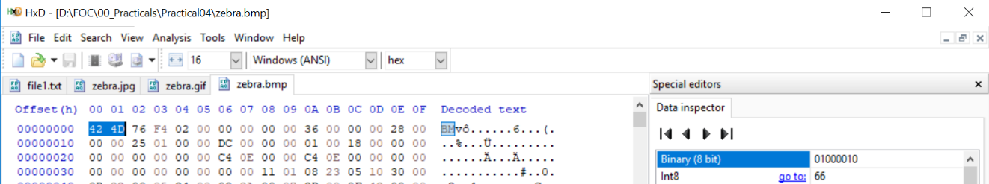

What are the **first 2 bytes**?

|  |  |  |
| --- | --- | --- |
| **offset** | **00** | **01** |
| Byte | 01000010 | 01001101 |
| Character | B | M |

1. Visit web site <https://en.wikipedia.org/wiki/List_of_file_signatures> to find out the meaning of above hex code

|  |
| --- |
| Hex code: 42 4D  ISO 8859-1: BM  Offset: 0  Extension: bmp  Description: BMP file, a bitmap format used mostly in the Windows world |

1. (optional)  
   Download the file at <https://drive.google.com/open?id=1vf0SBkI1LdWQvYmK9yM5AyJ0fHKE6DHR>

How can you view it as an image?

|  |
| --- |
| Open the downloaded file in HxD.  Observe the Hex code.  Go to web site <https://en.wikipedia.org/wiki/List_of_file_signatures> to find the meaning of the Hex code. Using the command ‘Ctrl + F’, type in the first 2 Hex Codes. Use the arrows to navigate and look for any Hex signatures that correspond to the first few Hex codes shown in the HxD.  Hex code is determined to be: 42 4D  ISO 8859-1: BM  Extension: bmp  Therefore, the file should be saved using the file extension ‘.bmp’ to view the file as an image. |

**Hint:**

* Open the file using HxD
* Visit web site <https://en.wikipedia.org/wiki/List_of_file_signatures> to find out the meaning of above hex code
* Rename the extension of the file

*End of Practical*